EXPT NO:4 | Visual encoding of data
DATE: 20.01.2026 | Visual encoding of data

PRE-LAB QUESTIONS
- How does the human visual system process visual variables?
The human visual system quickly interprets visual variables such as color, size, shape, and position. It processes these attributes in parallel, allowing patterns and differences to be recognized rapidly. Effective visual encoding leverages these abilities to communicate information efficiently without excessive cognitive effort.
- Why is improper encoding misleading in analytics?
Improper encoding can exaggerate, hide, or distort patterns in data. Misuse of colors, scales, or sizes may lead users to incorrect conclusions. In analytics, such misrepresentation can result in faulty insights, biased interpretations, and poor decision-making, especially in high-impact domains like public policy.
- What are perceptual limitations in visualization?
Humans have limited ability to distinguish small differences in color, size, or shape. Overloaded visuals cause clutter and confusion. Depth, area, and color gradients may also be misjudged, making it difficult to accurately interpret complex or dense datasets without careful design.
- How does color choice affect interpretation?
Color choice strongly influences perception and emotional response. Certain colors highlight importance, severity, or danger, while poor color contrast can obscure information. Incorrect or inconsistent color use may confuse users, whereas appropriate palettes enhance clarity, comparability, and correct interpretation of data patterns.
- Why should AI dashboards be perceptually optimized?
AI dashboards should be perceptually optimized to ensure users correctly understand model outputs. Clear visual encoding reduces cognitive load, improves trust, and prevents misinterpretation. Optimized visuals help decision-makers quickly grasp insights, making AI systems more transparent, reliable, and actionable.
OBJECTIVE: To apply effective visual encoding principles for meaningful data communication.
SCENARIO: A city traffic department analyzes accident data to identify high-risk zones and accident severity patterns.
IN-LAB TASKS (Using R Language) • Encode severity using color gradients • Represent accident frequency using size • Use shape to indicate accident type

CODE:
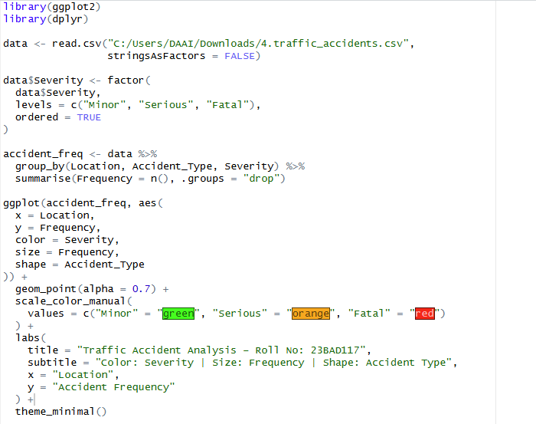

OUTPUT:
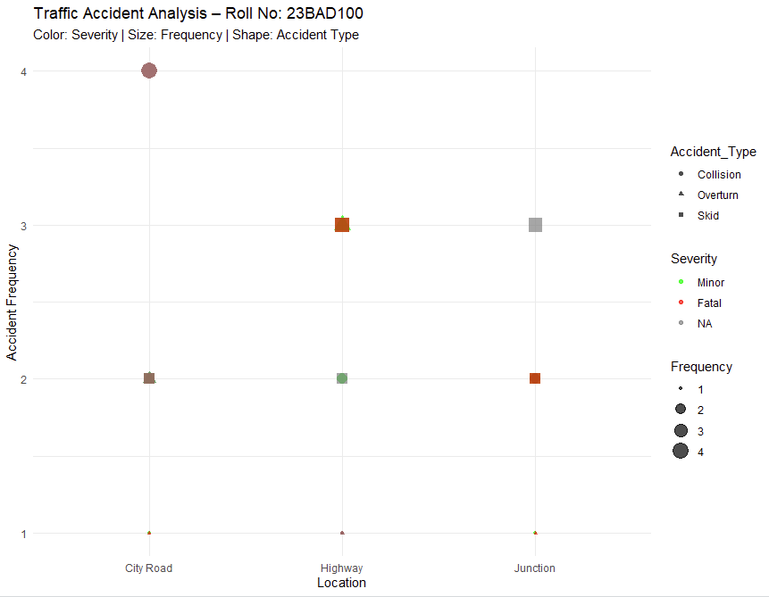

POST-LAB QUESTIONS
- Which visual variable best conveys severity and why?
Color best conveys severity because the human visual system quickly associates color intensity with risk levels. Using intuitive colors like green for minor, orange for serious, and red for fatal accidents allows immediate recognition of high-severity cases and supports fast decision-making in traffic safety analysis.
- How can poor encoding mislead policy decisions?
Poor visual encoding can hide critical accident patterns or exaggerate less important ones. If severity or frequency is misrepresented, policymakers may allocate resources incorrectly, overlook high-risk locations, or implement ineffective safety measures, leading to reduced impact of traffic management strategies.
- What precautions should be taken for color-blind users?
Visualizations should use color-blind-friendly palettes and avoid relying solely on color to convey information. Redundant encodings such as size, shape, and clear labels should be included so users with color vision deficiencies can accurately interpret accident severity and types.
- How does visual encoding affect AI explainability?
Effective visual encoding makes AI outputs easier to understand by clearly presenting patterns, severity levels, and trends. Well-designed visuals improve transparency and trust, allowing users to interpret AI-driven insights confidently, while poor encoding obscures reasoning and reduces explainability.
- Suggest improvements for large-scale public dashboards.
Large-scale public dashboards should use simplified layouts, interactive filtering, consistent color schemes, and scalable symbols. Clear legends, accessibility support, and responsive design enhance usability and ensure accurate interpretation of traffic risk information by diverse users.

LEARNING OUTCOME: Students learn perceptually effective visual communication for AI systems.

ASSESSMENT
Description | Max Marks | Marks Awarded
Pre Lab Exercise | 5
In Lab Exercise | 10
Post Lab Exercise | 5
Viva | 10
Total | 30
Faculty Signature

Repository Link:
https://github.com/Srikanth-18005/U18AII5202_23BAD117

